Food Management System

Use-Case-Realization Specification: Sign Up

Version <1.0>

Revision History

|  |  |  |  |
| --- | --- | --- | --- |
| **Date** | **Version** | **Description** | **Author** |
| <24/12/2020> | <1.1> | Final Draft | Nguyen Thi Ngoc Anh |

Table of Contents

1. Introduction 2

1.1 Purpose 2

1.2 Scope 2

1.3 Definitions, Acronyms, and Abbreviations 2

1.4 References 2

1.5 Overview 2

2. Flow of Events—Design 2

3. Derived Requirements 2

Use-Case-Realization Specification: Sign Up

# Introduction

## Purpose

This document describes how the Sign Up Use-Case is realized within the design model, in terms of collaborating objects.

## Scope

This document applies to the Food Management System which will be developed by TAT Restaurant.

## Definitions, Acronyms, and Abbreviations

None.

## References

None.

## Overview

In the following section, Use-Case Realization Specification of the Sign Up Use-Case of the Food Management System is provided in detail. The first section is a textual description of the Use-Case specification. The following section contains diagrams (sequence and collaboration diagrams) describing how the use case is realized in terms of collaborating objects. The third section includes class diagrams with relationships that participate in the realization of the use case. The last section is an analysis of all requirements, such as non-functional requirements, on the use-case realization that are not considered in the design model, but that need to be taken care of during implementation.

# Flow of Events—Design

**2.1. Use Case Specification (script)**

|  |  |
| --- | --- |
| **Use Case** | Sign Up |
| **Description** | A user creates an account |
| **Actor(s)** | Customer |
| **Flows of Events** |  |
| **Basic Flow** | |
| 1. Customer goes to registration page or select registration option while try to login the system 2. The system prompts user for registration information: username, password, etc 3. The customer enters their information. 4. The system validates user information. 5. The system creates a new user base on entered information 6. The system saves the new user to database. | |
| **Alternative Flows** | |
| **Title** | **Description** |
| Invalid Information Entered | 1. User enter invalid information  2. System displays information with appropriate message to correct invalid username or password. |
| **Pre-conditions** | |
| The user is not logged in the system (guest). | |
| **Post-conditions** | |
| **Title** | **Description** |
| Success | Success message is prompted and user is returned to the homepage. |
| Failure | The user is unable to log in for one or more reasons and an error is prompted. |
| **Extension Points** | |
| None. | |

**2.2. Sequence Diagram:**

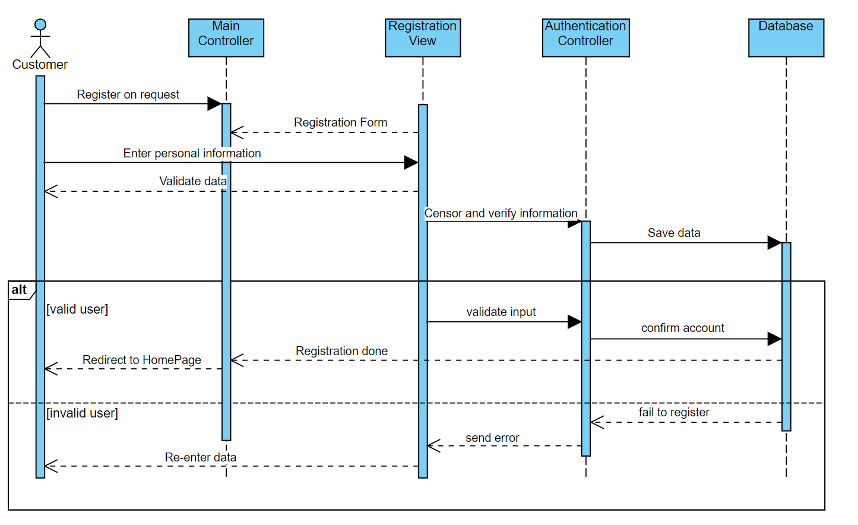

**2.3. Class Diagram:**

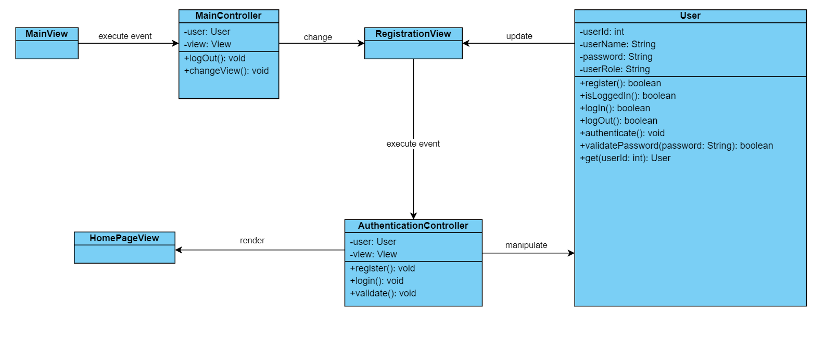

# Derived Requirements

None.